Step 2 – Regional profile
Tool 2.2 – Regional circular economy assessment report template
Activity 2.2 – Compiling and analyzing the results

IN SHORT, THIS TOOL IS USED TO…
- Summarize, consolidate and present the information collected during Activity 2.1 – Consulting stakeholders in simple terms using, for instance, Tool 2.1 – Regional circular economy assessment questionnaire
- Update Tool 1.2.1 – List of stakeholders in Activity 1.2 – Managing stakeholders by including the new data obtained during the regional assessment.

HOW THE TOOL WORKS
The report template contains:
- Instructions for the content to be included.
- Generic portions of text that do not necessarily apply to the regional context.
- References, tables and figures with automatic numbering. The table of contents, which is also automatically generated, must be updated once the document has been completed.
Adapt the template, including the cover page, and delete non-relevant sections.

Regional circular economy assessment of [name of region]

Table of contents

INTRODUCTION 2
1. Methodology 4
1.1. Presentation of Project Team and completion of survey 4
1.2. Promotion of survey 4
2. Results of the industrial, commercial and institutional sector questionnaire 4
2.1. Respondents 4
2.2. Analysis of responses to each question 5
2.3. Priority areas of action 6
2.4. Observations and areas for reflection 6
3. Results of the Economic Development Organization (EDO) questionnaire 6
3.1. Respondents 6
3.2. Analysis of responses to each question 6
3.3. Priority areas of action 7
3.4. Observations and areas for reflection 7
4. Results of municipal sector consultation 7
5. Results of public participation 7
6. Results of add type of consultation 7
7. Identification and analysis of stakeholders 8
8. Analysis of current and future projects 8
9. Supplemental information 8
CONCLUSION 9
REFERENCES 10
Appendix 1 – STAKEHOLDER MAPPING 11

INTRODUCTION

Context for the development of a regional CE roadmap in Enter name of region
WHAT IS A ROADMAP?
A regional circular economy (CE) roadmap is first and foremost a regional collaborative initiative aimed at engaging organizations to transition toward a circular economy. Created in close cooperation with regional stakeholders, the roadmap provides a framework for sustainably developing the circular economy on a regional scale. It provides a regional vision, strategic directions and collective objectives to be met according to a timetable set by the stakeholders. The roadmap proposes a multitude of coherent strategic, financial, regulatory and technological actions, as well as others related to service and procurement.
With its long-term systemic vision, the roadmap brings together stakeholders around a project full of economic, environmental and social benefits. Its development and implementation engage local driving forces in all sectors – public, industrial and civil. All are concerned.
The roadmap is a key activity in the transition to a circular economy that reflects local concerns and issues. It is precisely aligned with each region’s goals, needs and capacities. It also ensures that regional directions are in line with government policies and action plans. To avoid duplication, the roadmap is integrated into its ecosystem and maintains a dialogue with its stakeholders at all levels. This bidirectional alignment has the roadmap and the regional directions converge toward the same goal: transition to a circular economy.
REGIONAL CE ROADMAP PROJECT FOR ENTER NAME OF REGION
Add summary information on the Leader, the context in which the roadmap is being developed, and the broad outline of the approach.
A ROADMAP THAT IS PART OF LOCAL DIRECTIONS
To create linkages with current initiatives, add the alignments with local, regional and national policies and directions.
A COLLABORATIVE INITIATIVE CONSISTING OF FIVE STEPS
The regional roadmap development initiative of add name of region consists of five steps. This methodology is an adaptation of the one proposed in the Toolkit for Developing and Implementing a Regional Circular Economy Roadmap: Guide and Tools (RECYC-QUÉBEC, 2022).

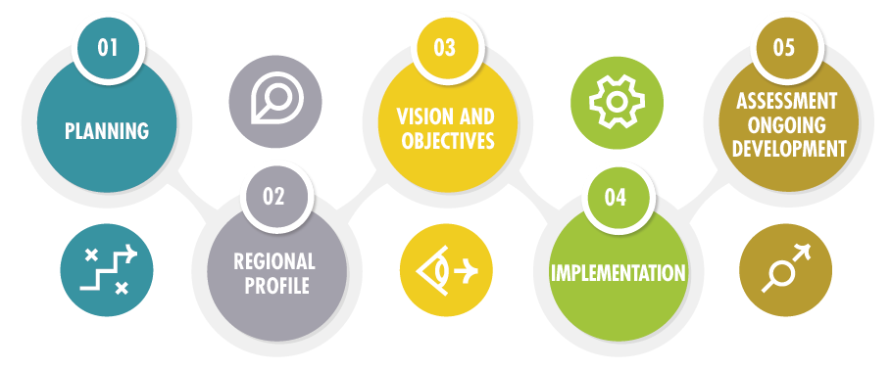
Figure 1 – Methodology for developing a roadmap

Summarize what was done in Step 1 – Planning based on the tools used as well as the main decisions taken for the development of the regional CE roadmap.

To carry out Step 2 – Regional profile, a regional survey was done via a questionnaire handed out to the entire regional ecosystem. Public participation activities were also set up, with the following objectives:
- Increase knowledge and understanding of the local ecosystem by identifying the key business sectors and the stakeholders. Perform an analysis by area of activity to obtain results by project.
- List current CE practices as well as initiatives being considered.
- Identify obstacles and levers. Identify significant correlations.
- Identify the potential for integrating new CE strategies by the stakeholders and prioritize the actions.
- Identify stakeholder needs to facilitate the adoption of CE strategies.
- Guide reflection and strategic planning in Step 3 – Vision and objectives.
- Engage stakeholders around the roadmap project.
- Guide the development of the roadmap that will be drafted in Step 4 – Implementation.
Two versions of the questionnaire were created to meet the specific needs of the target audiences in the circular economy deployment projects:
- ICI questionnaire – Version for the industrial, commercial and institutional (ICI) sector of all types and all areas of activity.
- EDO questionnaire – Version for economic development organizations (EDOs).
Regarding public participation, add the list of public participation activities along with the associated information (who, what, where, when, how, how much) were carried out to consult all the stakeholders in the region for the sake of representativeness and diversity.

- Methodology
  - Presentation of Project Team and completion of survey
The initiative carried out in add name of region is conducted by a Project Team made up of add information. The survey was conducted over a period of add duration of data collection period, between add data collection dates. The platform that was used was add name of questionnaire tool that was used (Google Forms, SurveyMonkey, etc.), which allowed the results to be more easily analyzed.
  - Promotion of survey
Various communication channels were used to maximize the response rate and ensure proper ecosystem representativeness:
- Professional networks of the organizations making up the Project Team.
- Social networks.
- Local media.
- Other. Specify.

- Results of the industrial, commercial and institutional sector questionnaire

2.1. Respondents
The questionnaire was completed by enter number of respondents found among the following areas of activity.

Table 1 – Breakdown of ICI questionnaire respondents by area of activity
Area of activity | Number
Agriculture, forestry, fishing and hunting
Arts, entertainment and recreation
Retail trade
Wholesale trade
Construction
Manufacturing
Accommodation and food services
Information and cultural industries
Administrative services, support services, waste management and sanitation services
Educational services
Professional, scientific and technical services
Public services
Health care and social assistance
Transportation and warehousing
Don’t know
Other

If allowed by the software used to send the questionnaire, add other tables and diagrams that depict the representativeness of the respondents (e.g., number of employees by organization and geographic location).

2.2. Analysis of responses to each question
Include the tables resulting from the data analysis with the software used to send the questionnaires. Add short explanatory paragraphs for each question.
An analysis of the correlations between the responses based on Regional County Municipality (RCM) or other significant factors is important in this section.
If questions were asked on generated materials and current sorting, compile the results in a table in this section.

2.3. Priority areas of action
This section presents the findings stemming from the cross-sectional analysis of the responses obtained for each respondent’s area of activity. For the ICI sector, select, for instance, the value chain, niche or strategic priorities of the organizations.
The collected data reveal similarities and differences among the different surveyed groups (e.g., based on area of activity, geographic location, size of organization). The priority analysis provides tangible direction to the Project Team in subsequent steps.

2.4. Observations and areas for reflection
This section critically reviews the results and highlights the key findings based on the analysis of the responses to the previous sections (2.2 and 2.3). These observations will guide Step 3 – Vision and objectives.

- Results of the Economic Development Organization (EDO) questionnaire

3.1. Respondents
The questionnaire was completed by enter number of respondents economic development organizations. To ensure confidentiality, the list of respondents is not disclosed in this report. Add information related to the representativeness of the respondents and its impact on the data analysis.

3.2. Analysis of responses to each question
Include the tables resulting from the data analysis with the software used to send the questionnaires. Add short explanatory paragraphs for each question.
An analysis of the correlations between the responses based on Regional County Municipality (RCM) or other significant factors is important in this section.

Question 1.1 – The three priority reasons are:

Question 1.2 – The three priority sectors are:

3.3. Priority areas of action
This section presents the findings stemming from the cross-sectional analysis of the responses obtained for each respondent’s area of activity. For EDOs, select, for instance, the value chain, niche or strategic priorities of the organizations.
The collected data reveal similarities and differences among the different surveyed groups (e.g., based on area of activity, geographic location, size of organization). The priority analysis provides tangible direction to the Project Team in subsequent steps.

3.4. Observations and areas for reflection
This section critically reviews the results and highlights the key findings based on the analysis of the responses to the previous sections (3.2 and 3.3). These observations will guide Step 3 – Vision and objectives.

- Results of municipal sector consultation

If applicable.

Use the numbered sections in the previous section and adapt the content to the other consultation activities that were carried out.

- Results of public participation

Use the numbered sections in the previous section and adapt the content to the other consultation activities that were carried out.

- Results of add type of consultation

Use the numbered sections in the previous section and adapt the content to the other consultation activities that were carried out.

- Identification and analysis of stakeholders

This section presents the stakeholders and analyzes the relations to be built with each one for the development of the roadmap. Once the regional assessment has been completed:
- Rank the main stakeholders according to the Interest/Influence Matrix. The detailed table presented in a landscape format can be found in the appendix.
- Update Tool 1.2.1 – List of stakeholders by including the new data.

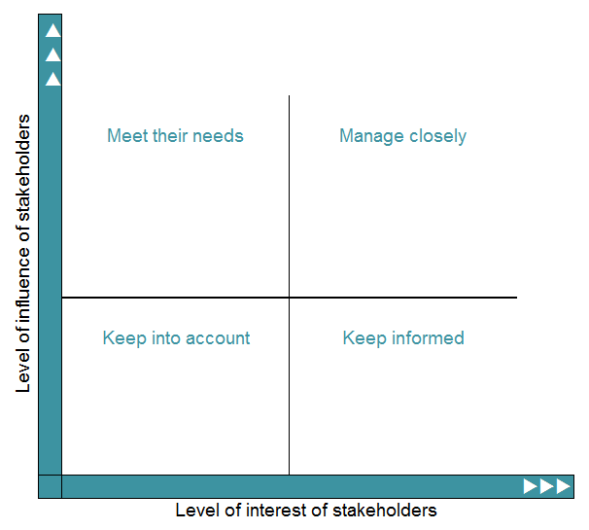
Source: BOREALIS. 2018. Stakeholder Mapping: When, Why, and How to Map Stakeholders. https://www.boreal-is.com/blog/stakeholder-mapping-identify-stakeholders/

- Analysis of current and future projects

This section is designed to complete the regional analysis by indicating current or future projects that will have an impact on the roadmap.

- Supplemental information

If necessary, add any information that may help better understand the regional transition to a circular economy. For instance, information that is known and sufficiently reliable, but does not appear in the responses to the questionnaires, or areas of reflection to guide roadmap development.
CONCLUSION

The regional assessment showed the progress being made in the transition to a circular economy.
It revealed current ICI practices as well as their future goals. An analysis of the questionnaire responses revealed their needs and enabled them to be prioritized. This data will also be useful for guiding the Project Team toward the roadmap directions, objectives and actions. Provide a one-sentence summary of the findings made following the analysis of the ICI questionnaire.
The assessment for the EDOs was useful for engaging the ecosystem and determining the intentions to modify the offer of assistance by the economic development advisors, along with their needs and expectations. Provide a one-sentence summary of the findings made following the analysis of the EDO questionnaire.
In its effort to engage all the ecosystem actors, the Project Team also implemented public participation mechanisms to extend the pool of stakeholders involved in the roadmap development and implementation process. Provide a one-sentence summary of the findings made following the consultation and participation activities.
Lastly, the correlated analysis of the responses provided a clear picture based on the area of activity and the various RCMs that make up the region. This valuable information will be used throughout the roadmap development methodology. By identifying the stakeholders, the Project Team can determine the most proactive ones who can increase their involvement and act as agents of change to ensure the transition of enter name of region to a circular economy.

REFERENCES

BOREALIS, 2018. Stakeholder Mapping: When, Why, and How to Map Stakeholders.
www.boreal-is.com/blog/stakeholder-mapping-identify-stakeholders/

RECYC-QUÉBEC, 2022. Toolkit for Developing and Implementing a Regional Circular Economy Roadmap: Guide and Tools.
https://www.recyc-quebec.gouv.qc.ca/sites/default/files/documents/guide-methodologique-fdr-ec-english.pdf

Appendix 1 – STAKEHOLDER MAPPING

Procedure:
- Adapt the list of stakeholders to the regional context.
- Supplement Tool 1.2.1 – List of stakeholders with the analysis of results obtained during the stakeholder consultation.
- Complete the following table based on the information compiled in Tool 1.2.1 – List of stakeholders.

Table 2 – Stakeholder mapping
Stakeholder | Reciprocal expectations |  | Interest/influence matrix |  | Strategic importance | Notes
Who?  Specify the stakeholder  (examples on the next page) | Stakeholder’s expectations of the Leader | Leader’s expectations of the stakeholder | Interest in project | Influence on project | 1 – Keep into account  2 – Keep informed  3 – Meet their needs  4 – Manage closely
Add surveyed and/or known stakeholders below. To facilitate surveying, create major stakeholder categories. Create your own categories that are better suited to your regional realities.  Use the notes section judiciously to document strategic aspects or potential partnerships with the various stakeholders.  Delete this line from the Word table. |  |  |  |  | IMPORTANT: CONFIDENTIALITY  Based on the target audiences to whom the Regional CE assessment is released, the Project Team must adapt the level of information and confidentiality to be maintained.

Stakeholder | Reciprocal expectations |  | Interest/influence matrix |  | Strategic importance | Notes
Ministries and public agencies
Funders
Municipalities
EDO
Environmental organizations
ICI sector
Citizens

