Step 2 – Regional profile
Tool 2.1 – Regional circular economy assessment questionnaire
Activity 2.1 – Consulting the stakeholders

IN SHORT, THIS TOOL IS USED TO…
- Collect the data needed to produce the regional assessment report (Activity 2.2 – Compiling and analyzing the results, Tool 2.2 – Regional circular economy assessment report template).

HOW THE TOOL WORKS
The questionnaire contains:
- Instructions for the content to be included.
- Generic portions of text that do not necessarily apply to the regional context.
Adapt the model and remove non-relevant sections.
The questionnaire can be reproduced via an online survey.
Two versions of the questionnaire were created to meet the specific needs of the target audiences in the circular economy (CE) deployment projects:
- Version for industrial, commercial and institutional (ICI) sector of all types and areas of activity.
- Version for economic development organizations (EDOs), including those involved in social economy.
  - If needed, adapt this version of the questionnaire when consulting the municipal sector.

5 | Tips for boosting  the questionnaire response rate
- Specify the subject of the solicitation email or newsletter.
- Clearly reiterate the purpose of the questionnaire. Provide the context of the overall initiative. Remind respondents of the potential benefits.
- Customize the content of the message. Share examples of local success stories.
- Emphasize confidentiality and thank the respondents.
- Offer support for responding to the questionnaire. Provide the contact information of the Leader in charge of the questionnaire.

Target the entire ecosystem
In addition to the ICI sector and EDOs, the other interest groups, such as environmental groups and the public, must also be consulted and included in the process. Consulting and engaging these stakeholders enable the Project Team to include their expectations and suggestions when the roadmap is being developed, which in turn facilitates their future collaboration.
Each region has a unique ecosystem. There is a wide variety of tools to refer to and have stakeholders participate in. Varying the tools and adapting them to the various stakeholders allow the ecosystem engagement to be broadened.
- To consult the municipal sector, more specifically if it is not directly involved in the development of the roadmap, adjust the version of the questionnaire sent to EDOs.
- An open forum is well suited to public meetings. It creates a space for open dialogue that is suitable for direct discussion, unlike the questionnaire.
The consultation and participation methods are key factors in the social acceptability of the projects and empowerment.

Industrial, commercial, and institutional sector VERSION

Name of recipient
An increasing number of organizations across Quebec are including circular economy (CE) strategies in their business models and we are curious to know if you are one of them. Have you already started or would like to start to transition to a circular economy soon?

Add an overview of your project here.
In this initiative, Name of initiative leader would like to consult the stakeholders to increase the offer of support to regional and local organizations in transitioning to a circular economy. To do so, the Project Team has developed a short multiple-choice questionnaire.
Your confidential responses will be used to draw up and launch a regional CE roadmap. In responding to this questionnaire, you concretely help us identify the most promising strategies for yourself and for regional organizations:
- Generate savings and additional revenue through the sale of by-products.
- Favour the development of business relations between your organization and local organizations.
- Reduce your waste management costs.
- Reduce your environmental impact.
- Create and maintain jobs.
- Increase your organization’s appeal and create value.
Thank you for taking 10 minutes to complete this confidential questionnaire.

Confidentiality policy
In the project’s confidentiality policy, specify the terms for secure data use.

Respond to the questionnaire in a few minutes Add the link or a button (option available in some newsletter templates) to the online questionnaire.

Deadline: Add the deadline for responding to the questionnaire and the return address (if the survey is not being done online).

Before completing the questionnaire, learn about the concept of circular economy (CE) by referring to the supplementary information below.

Thank you for your valuable contribution!

According to the platform used for the questionnaire, it may be useful to add the following supplementary information. This information is designed to ensure that all respondents have a basic understanding of the concept of CE before completing the questionnaire. However, it is not mandatory to add it since the questions are formulated so that they can be understood by respondents with minimal knowledge of the CE.
Supplementary information on the circular economy
The circular economy is an economic model that consists in:
- Rethinking our production and consumption patterns to consume fewer resources and protect the ecosystems that generate them.
- Optimizing the use of the resources that are already circulating in our societies by intensifying product use, extending the life of products and components, and giving resources a new life.

The various strategies are found in four main categories shown in a simplified diagram:

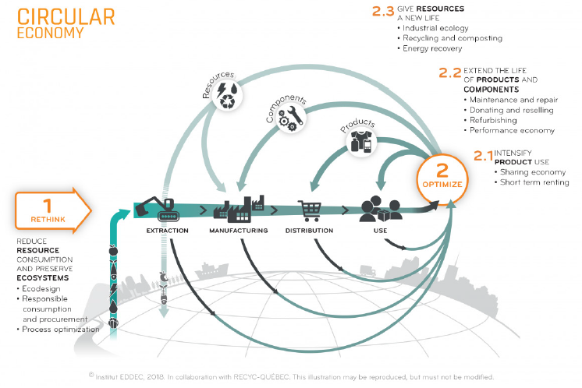

TO LEARN MORE:
https://www.quebeccirculaire.org/static/h/issues-and-definition.html

How to respond to the questionnaire
1) Answer the questions to the best of your ability. There are no right or wrong answers.
2) Need some help? Contact Enter contact information of Leader in charge of the questionnaire.

Part 1
Your current and potential circular economy practices

1.1 Among the practices proposed in the following table of circular economy (CE) practices, indicate the status of each one within your organization: adopted, considered, not considered, don’t know, or not applicable.

Status of circular economy practices
CE practice | Practice status
 | Adopted | Considered | Not considered | Don’t know or not applicable
We are reducing our resource use (materials, water and energy):
By favouring responsible procurement
By optimizing our processes
By adopting energy-efficient practices
By optimizing the packaging and transportation of our products and services
By increasing the life of our products and services as well as their repairability
By designing products with components made of materials that can be reclaimed
Renting, pooling and the sharing economy are part of our practices, because:
Our underutilized products, spaces or equipment are made available to other organizations
We share products, spaces or equipment with other organizations
The products, spaces or equipment that we occasionally use for our work are rented or leased over short periods rather than purchased
Our products and services are rented or leased to our clients (short- or long-term lease)
In our processes, we favour:
Products and services originating from the economy of functionality
Repairing rather than purchasing new products
Donating or reselling unused products or procuring second-hand products
Product maintenance
The reconditioning or repair of returned merchandise and end-of-use products
The collection of materials and products at end of life in view of recycling, composting or energy recovery

1.2 Is there any waste (residual materials) that could potentially be reclaimed by your organization or another?
- If so, name the main waste (residual materials) generated.
- Do you see any reclamation potential for this waste (residual materials)? If so, what kind?
A table with a list of materials can be found in the appendix. For a sub-group, it is recommended to perform a more detailed analysis of the generated materials and current sorting.

1.3 Which projects from the following list do you expect to implement in your organization in the next few years?
☐ Construction, renovation, relocation or expansion.
☐ Energy transition.
☐ Development of new markets or products and services.
☐ Modernization of equipment and acquisition of clean technology.
☐ Process automation and robotization.
☐ Obtaining sustainable development certification (e.g., LEED, Lean, ISO, BCorp).
☐ None.
☐ Don’t know.
☐ Other Specify.
Comments Enter your comments here.
Part 2
Your motivation and needs for carrying out circular economy projects

2.1 Why have you added CE strategies in your organization or why are you interested in adding them? Select the three most important reasons.
☐ To generate new sources of revenue.
☐ To reduce expenses.
☐ To reduce environmental impact.
☐ In response to a request from customers.
☐ To increase our market share.
☐ To attract and retain employees.
☐ To comply with current or future laws and regulations.
☐ To contribute to government environmental targets regarding greenhouse gas (GHG) emissions, the energy transition, or waste management.
☐ Don’t know.
☐ Other Specify.
Comments Enter your comments here.

  - What type of external support would you like to obtain to help your organization transition to a circular business model? Select all choices applicable to your organization.
☐ Understand the laws and regulations (municipal, provincial, federal or international) that apply to us in terms of the circular economy.
☐ Identify opportunities for our organization to transition to CE practices.
☐ Translate CE opportunities into concrete projects for our organization.
☐ Identify and have access to experts to help us carry out CE projects.
☐ Identify and obtain access to funding to help us carry out CE projects.
☐ Identify and have access to tools to help us carry out CE projects.
☐ None of the above.
☐ Other Specify.
Comments Enter your comments here.

Part 3 – Your influential role in developing the circular economy

  - Would you be willing to contribute to the advancement of the circular economy regionally? Check all choices applicable to your organization.
☐ We are prepared to share our expertise and best practices with other organizations.
☐ We are prepared to use our network to help other organizations carry out CE projects.
☐ We are ready to invest in another organization’s CE project.
☐ Don’t know or not applicable.
☐ I don’t wish to contribute. (Specify why in the comments. Is it because of a lack of knowledge, resources, etc.?)
☐ Other Specify.
Comments Enter your comments here.

Part 4 – Information on the respondent
  - Name of your organization: Name
  - Location of your organization: City
  - Number of employees: Number
  - Contact person: Name, title, phone, email
  - Area of activity

☐ Agriculture, forestry, fishing and hunting
☐ Arts, entertainment and recreation
☐ Retail trade
☐ Wholesale trade
☐ Construction
☐ Manufacturing
☐ Accommodation and food services
☐ Information and cultural industries
☐ Administrative services, support services, waste management and sanitation services
Comments Enter your comments here.

☐ Educational services
☐ Professional, scientific and technical services
☐ Public services
☐ Health care and social assistance
☐ Transportation and warehousing
☐ Other Specify.

Economic development organization (EDO) VERSION

Name of recipient
Experts around the world agree on the need to green our economy by including sustainability and circular economy strategies. However, Quebec’s circularity index is only 3.5%, which is much lower than the world average of 8.6% (Circle Economy and RECYC-QUÉBEC, 2021).
This major transition is occurring gradually and an increasing number of organizations across Quebec are making the transition. We are curious to know whether you are part of them. Have you already started or would like to start to transition to a circular economy soon?

Add an overview of your project here.
In this initiative, Name of initiative leader would like to consult the stakeholders to increase the offer of support to regional and local organizations in transitioning to a circular economy. The goal is to gain a better understanding of your intentions and anticipate the specific needs of economic development organizations (EDOs). To do so, the Project Team has prepared a short questionnaire consisting of six questions.
Your confidential responses will be used to draw up and launch a regional CE roadmap. In responding to this questionnaire, you concretely help us identify the most promising strategies for yourself and for regional organizations:
- Generate savings and additional revenue in the region through the sale of by-products.
- Favour the development of business relations between your organization and local organizations.
- Reduce waste management costs.
- Reduce the environmental impact.
- Create and maintain jobs.
- Increase your organization’s appeal and create value.
Thank you for taking 10 minutes to complete this confidential questionnaire.

Confidentiality policy
In the project’s confidentiality policy, specify the terms for secure data use

Respond to the questionnaire in a few minutes Add the link or a button (option available in some newsletter templates) to the online questionnaire.

Deadline: Add the deadline for responding to the questionnaire and the return address (if the survey is not being done online).

Before completing the questionnaire, learn about the concept of circular economy (CE) by referring to the supplementary information below.

Thank you for your valuable contribution!

According to the platform used for the questionnaire, it may be useful to add the following supplementary information. This information is designed to ensure that all respondents have a basic understanding of the concept of CE before completing the questionnaire. However, it is not mandatory to add it since the questions are formulated so that they can be understood by respondents with minimal knowledge of the CE.
Supplementary information on the circular economy
The circular economy is an economic model that consists in:
- Rethinking our production and consumption patterns to consume fewer resources and protect the ecosystems that generate them.
- Optimizing the use of the resources that are already circulating in our societies by intensifying product use, extending the life of products and components, and giving resources a new life.

The various strategies are found in four main categories shown in a simplified diagram:

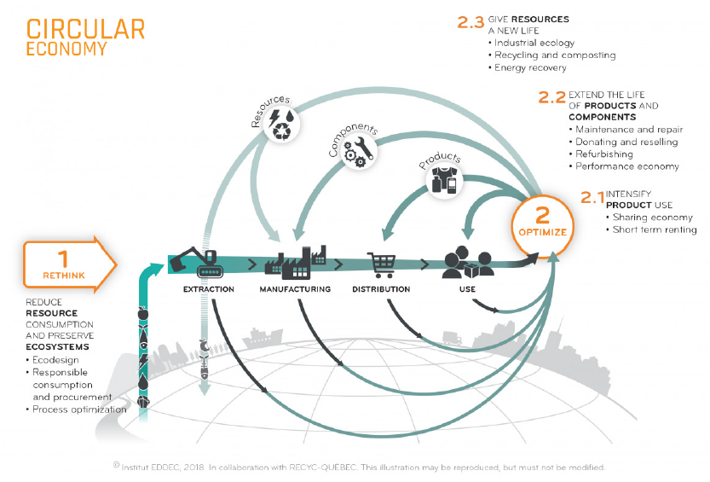
TO LEARN MORE:
https://www.quebeccirculaire.org/static/h/issues-and-definition.html

How to respond to the questionnaire
1) Answer the questions to the best of your ability. There are no right or wrong answers.
2) Need some help? Contact Enter contact information of Leader in charge of the questionnaire.

Part 1 – Circular economy in your region

1.1 Why is it important to increase the number of organizations adopting circular economy (CE) strategies in their business models in your region? Select the three most important reasons.
☐ To attract and retain employees.
☐ To reduce the environmental impact.
☐ To generate new sources of revenue.
☐ To reduce expenses.
☐ In response to a request from customers.
☐ Increase market share.
☐ To comply with current or future laws and regulations.
☐ Contribute to government environmental targets regarding greenhouse gas emissions, the energy transition, or waste management.
☐ Don’t know.
☐ Other Specify.
Comments Enter your comments here.

  - Select the three priority areas of activity among the following that have a strong potential for CE development in your service area.
☐ Agriculture, forestry, fishing and hunting
☐ Arts, entertainment and recreation
☐ Retail trade
☐ Wholesale trade
☐ Construction
☐ Manufacturing
☐ Accommodation and food services
☐ Information and cultural industries
☐ Administrative services, support services, waste management and sanitation services
☐ Educational services
☐ Professional, scientific and technical services
☐ Public services
☐ Health care and social assistance
☐ Transportation and warehousing
☐ Other Specify.
Comments Enter your comments here.

  - In these three priority areas of activity, provide examples of CE projects to be strategically implemented in your region. Why?
Enter your responses here.

1.4 If you can, provide examples of organizations that have implemented CE strategies in your region.
Enter your responses here.

Part 2 – Your influential role in the deployment of the circular economy

  - How, or through which services or assets, could your organization contribute to developing CE in your region? Select all applicable answers.
☐ Activation of an extensive network for carrying out CE projects.
☐ Sustainable development values integrated into our practices and promoted by management throughout our organization.
☐ Solid expertise in organizational support.
☐ Knowledge of the different financial levers that are available.
☐ Knowing which experts to solicit to carry out CE projects.
☐ Participating in established networks and communication platforms.
☐ Access to tools and methodologies that could help organizations carry out their CE projects.
☐ Other Specify.

  - Do you anticipate making changes to your service offering to meet the needs of organizations that would like to implement CE strategies? If yes, which ones:
☐ Provide CE-related training and support to clients.
☐ Develop CE consulting services for our clients.
☐ Provide CE-related training and coaching to our employees.
☐ Make sure to convey a clear message regarding CE to our clients, employees and members.
☐ Don’t know.
☐ Other Specify.

  - How can Enter name of roadmap Leader help you develop your expertise so as to better support organizations that wish to implement CE strategies? Select all choices applicable to your organization.
☐ Indicate the legislation (municipal, provincial, federal, international) that applies to organizations in relation to the circular economy.
☐ Identify CE opportunities for our clients.
☐ Translate CE opportunities into concrete projects.
☐ Identify and have access to experts to help us carry out CE projects, at the organizational and/or regional level.
☐ Having access to financial levers to help carry out CE projects.
☐ Having access to tools and methodologies to carry out CE projects.
☐ Other Specify.
Part 3 – Information on the respondent

  - Name of your organization: Name
  - Location of your organization: City
  - Number of employees: Number
  - Contact person: Name, title, phone, email

Comments Enter your comments here.

Appendix – Generated materials and current sorting
To obtain more detailed data on regional organizations’ residual materials management, a mapping by management method can be done (Table 1). To optimize its data collection and analysis efforts, the Project Team may target a few organizations based on criteria to be defined (e.g., sales, number of employees, priority areas of activity).

Table 1 – Residual materials management system based on management method
Please complete the following table by indicating the annual quantities generated in each box applicable to your organization. Indicate the unit of measure next to the quantity (e.g., kg, ton).
MATERIAL | MANAGE-MENT METHOD | Waste (municipal or private collection) | Municipal curbside collection of recyclable materials | Private specialized collection of recyclable materials | Municipal organic waste collection | Private organic waste collection | Given away | Sold | Waste-to-energy | Don't know
Office waste
Paper and cardboard
Plastic, glass and metal
Plastic film
Organic materials
Other (specify)
Commercial, industrial and institutional waste (from your warehouses, distribution centres and/or production lines)
Wood (e.g., pallets)
MATERIAL | MANAGE-MENT METHOD | Waste (municipal or private collection) | Municipal curbside collection of recyclable materials | Private specialized collection of recyclable materials | Municipal organic waste collection | Private organic waste collection | Given away | Sold | Waste-to-energy | Don't know
Cardboard
Paper
Flexible and rigid plastic
Glass
Ferrous metals
Non-ferrous metals
Textile and carpeting
Composite materials (e.g., epoxy-based)
Minerals
Solvents, acids and bases
Oil and grease
Paint, stains
Other hazardous waste
Electronic waste

MATERIAL | MANAGE-MENT METHOD | Waste (municipal or private collection) | Municipal curbside collection of recyclable materials | Private specialized collection of recyclable materials | Municipal organic waste collection | Private organic waste collection | Given away | Sold | Waste-to-energy | Don't know
Tires, rubber and elastomers
Food processing waste
Crop residues
Other objects or parts made up of several of the materials listed above
Primary sludge from wastewater treatment
Organic sludge from wastewater treatment
Machining or cutting sludge
Other industrial sludge made up of several of the materials listed above
Construction, demolition or renovation waste
Wood
Brick

MATERIAL | MANAGE-MENT METHOD | Waste (municipal or private collection) | Municipal curbside collection of recyclable materials | Private specialized collection of recyclable materials | Municipal organic waste collection | Private organic waste collection | Given away | Sold | Waste-to-energy | Don't know
Asphalt
Concrete
Other aggregates (e.g., backfill material)
Soil
Flexible and rigid plastic
Glass
Gypsum
Paint, stains and associated containers (pails)
Shingles
Furniture (e.g., chairs, tables)
Electrical waste
Insulation (e.g., foam, mineral wool, ceiling tiles)
Industrial glues, adhesives and caulking

REFERENCES

CIRCLE ECONOMY and RECYC-QUÉBEC. 2021. The Circularity Gap Report.
https://www.recyc-quebec.gouv.qc.ca/sites/default/files/documents/rapport-indice-circularite-en.pdf

